**ALL THINGS MAGICAL BY SIMON MATHEWSON, POP:**

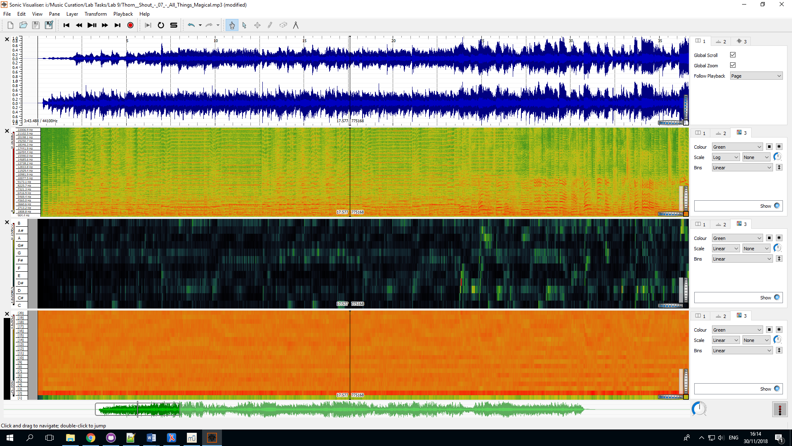

**DONT’ RAIN ON MY PARADE BY BARBRA STREISAND, MUSICAL THEATER:**

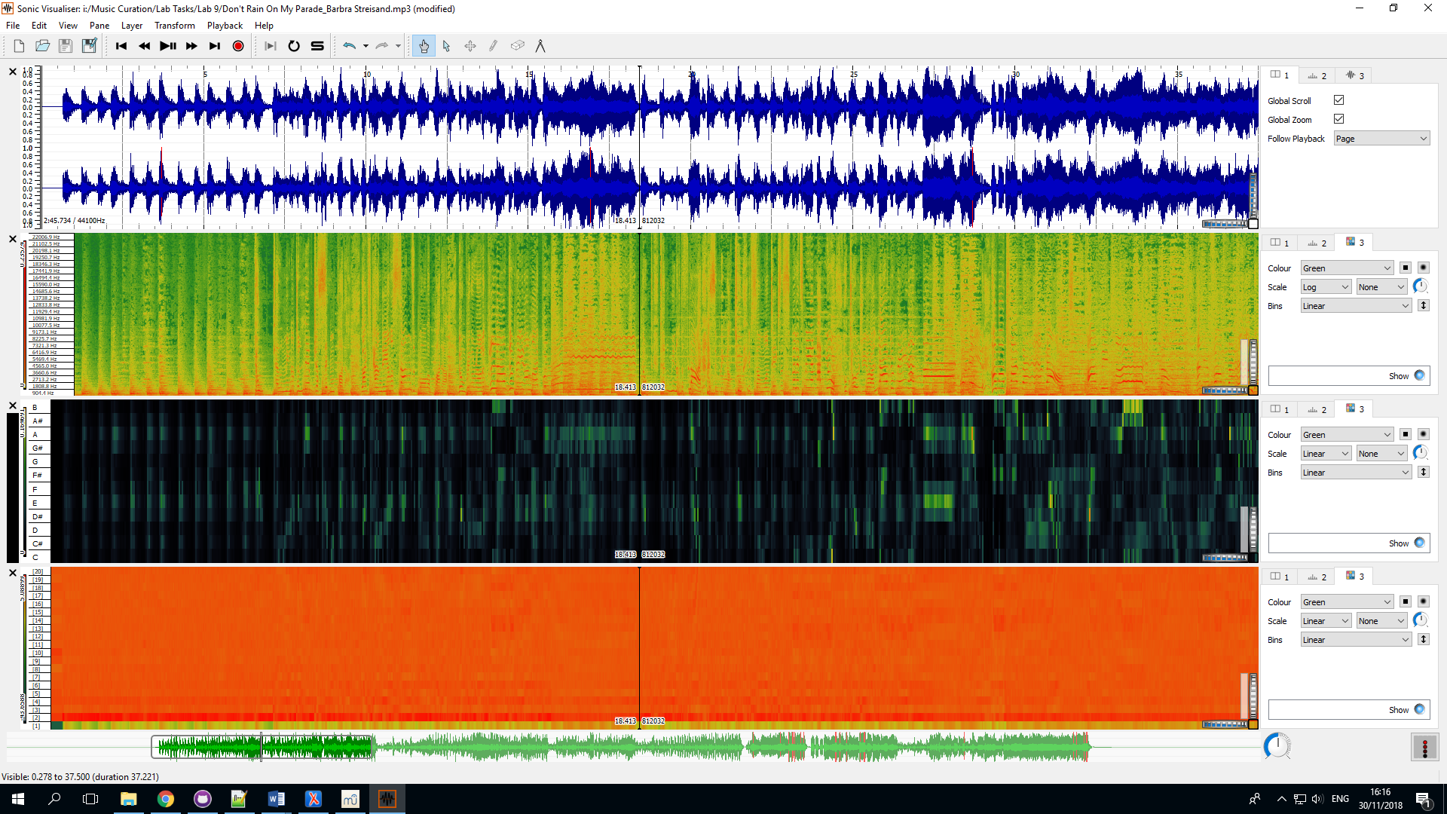

**DELIGHT BY DAN YAN-KEY, JAZZ:**

